**Hourly**

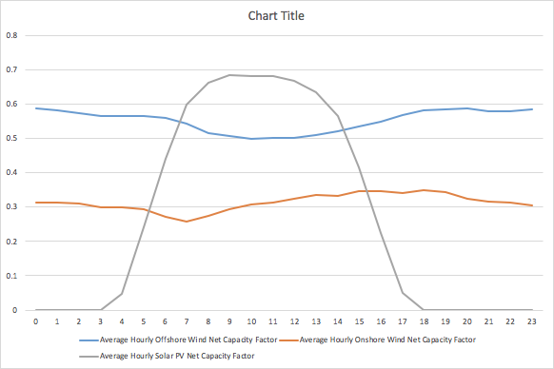

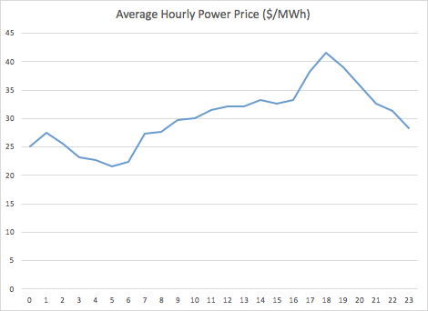

**Daily**

lol

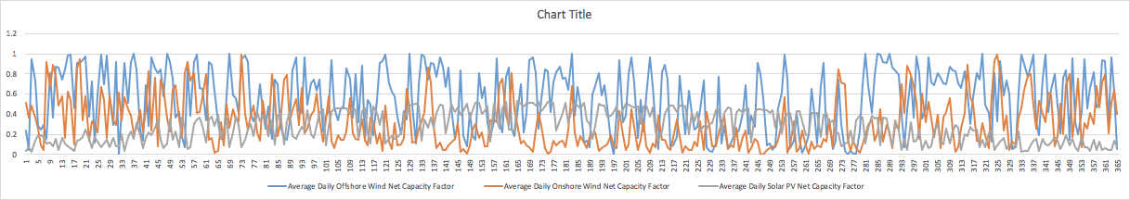

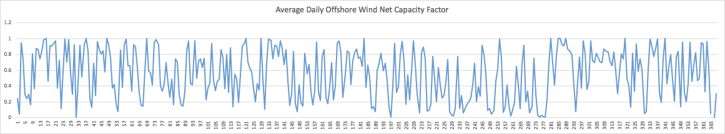

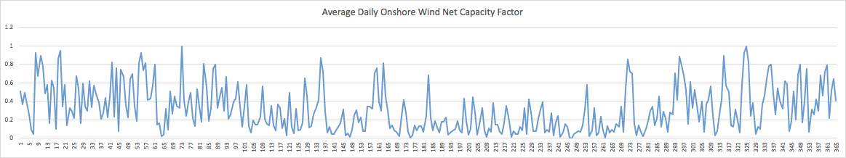

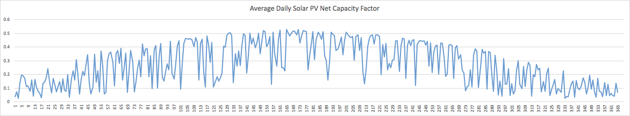

STDEV

* Offshore: 0.3050616
* Onshore: 0.244348053
* Solar: 0.152725173

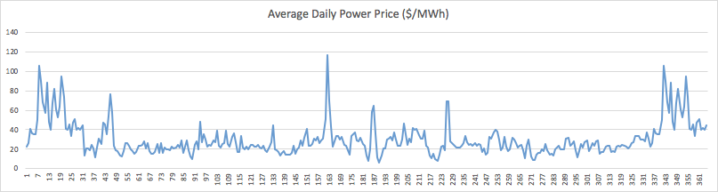

**Monthly**

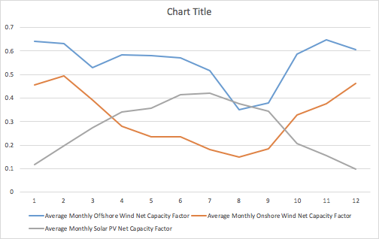

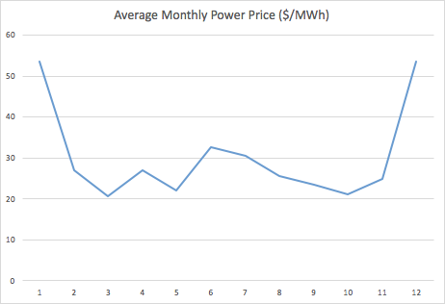

Total power price: $264,537.00

NOTES for utilization strategy:

Use demand response (or demand-side management) to shift flexible loads to a time when more renewable energy is available, and away from times when renewable generation is low. This requires that loads be capable of receiving and responding to price or control signals from the local utility or grid operator.